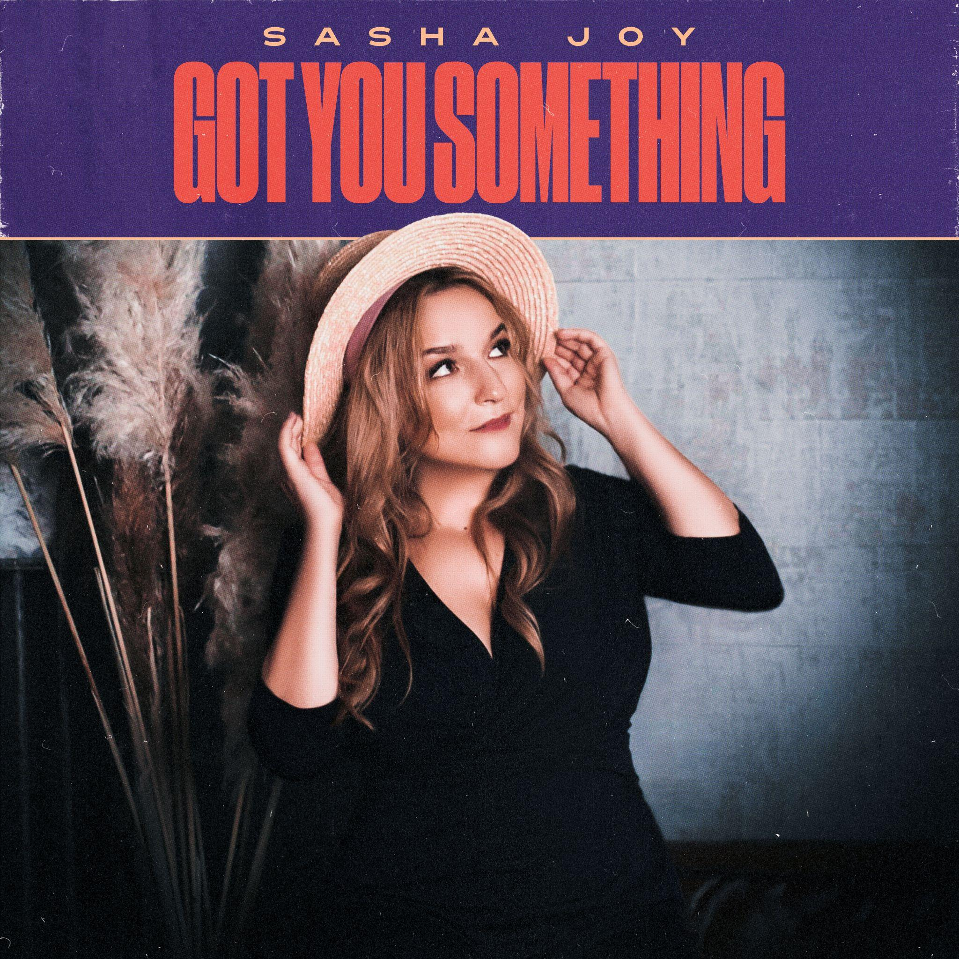

Sasha Joy Raises the Stakes with Boundary-Pushing, Fully Live-Recorded Single “Got You Something”
The clearest statement yet from an artist already cutting through with a distinctly arresting sound
With voice, groove, and emotional depth, Sasha Joy doubles down on the soulful, richly textured sound that’s earned her early critical praise, unveiling “Got You Something” on May 15, 2026 across all major platforms. Following prior acclaim — with EARMILK calling previous releases a “masterpiece” and “a brilliant effusion” — she delivers a soulful sound grounded in authentic musicianship and live energy that breaks through today’s digital-heavy landscape. The result is a track that blends timeless sounds with a new-era sensibility, bringing into sharp focus the qualities that define her: a singular vocal character, poignant songwriting, and a sound that is unmistakably hers.
“Got You Something” represents a decisive evolution of Sasha Joy’s already recognisable sound. Blending soul with pop, R&B, and funk, the track is the first in her catalogue to showcase entirely live instrumentation in drums, bass, guitars, percussion, and keyboards—a level of commitment increasingly rare in modern recording. A richly textured soundscape brings the groove to life and amplifies the track’s emotional arc. Her voice remains untouched by the conventional pitch correction tools commonly used today, revealing a vocal presence moving with clarity and rawness.
The theme of “Got You Something” explores a powerful human paradox: the realisation that even in moments of loss, life leaves us with something essential to take with us. Gliding between intimacy and intensity, Sasha Joy captures the bittersweet terrain of resilience: a space where melancholy, defiance, and hope exist side by side. The track’s rhythm and warm textures mirror that push and pull between fragility and strength. The song unfolds with emotional resonance, allowing listeners to recognise their own experiences within it. Carried by a voice of striking presence, it transforms an intimate reflection into a universally shared experience.
The song’s production brings into sharper focus the rhythmic fluidity and tonal palette critics are beginning to recognise as hallmarks of her style. Originally written and recorded in London, it took final shape in a specialist studio celebrated for capturing warm live instrumentation. The result balances London’s rhythmic vitality with meticulous detail, keeping Sasha Joy’s voice firmly at the centre. Producer Sanga Toto’s refined touch lets every element breathe, crafting rich arrangements to give the track an enthralling pulse. The final master was completed by Chab at Chab Mastering, a Grammy-winning mastering engineer known for his sonically sculpted work with artists like Justin Timberlake and Daft Punk. Rooted in voice-led writing, the song pairs an immersive sound with incisive lyrics, allowing every component to carry meaning and weight.
As audiences and tastemakers rediscover organic vocals and musicianship, her work challenges digital uniformity, putting voice, groove, and human nuance front and center, while maintaining a refined production finish.
On this track, Sasha Joy shapes a musical language that is instantly recognisable, rooted in classic soul while boldly forging a new sound all her own. With a distinct vocal and sonic identity that cuts through today’s landscape, she delivers a fully realised track—cohesive, original, and vibrantly alive, pointing toward a broader shift in contemporary music. Defined by striking clarity and vision, Sasha Joy’s sound lands with authority, standing as a compelling presence in today’s music climate.
Contact:
team@truesoundmusic.com
Press Images:
sashajoy.com/press-images
Artist Bio:
https://www.sashajoy.com/bio
Artist Instagram:
instagram.com/sashajoy.music

